Smart Manufacturing Data Hub (SMDH) - AWS Architecture Design

1. Executive Summary
The SMDH platform is a multi-tenant IoT analytics system that collects data from manufacturing sensors and gateways via native MQTT protocol and provides real-time insights. The architecture optimises for persistent, high-frequency sensor connections while maintaining strict tenant isolation for up to 30 manufacturing SMEs.

1.2 Core Architecture Principle
The SMDH platform uses AWS IoT Core as a managed MQTT broker. All sensor data sources connect via MQTT - either directly (DevTank OSM with Wi-Fi) or through LoRaWAN gateways (Milesight UG65). This single, protocol-native approach provides:
- Persistent connections for high-frequency sensors (1 Hz updates)
- Native QoS guarantees (at-least-once delivery)
- Built-in device registry and authentication
- Integrated buffering and ordering via Kinesis
No custom validation layers, no HTTP polling overhead, no protocol conversions—just pure MQTT from edge to cloud.

1.3 Key Business Drivers
Driver | Architectural Impact
Up to 30 separate tenants | Database-per-tenant isolation in Snowflake
5-10 sensors per site | Modest but steady streaming data volume
MQTT-native sensors | AWS IoT Core as central MQTT broker
Real-time monitoring | Sub-minute data latency requirements
Distributed gateways | Multi-AZ deployment, regional endpoints

2. Requirements Traceability

2.1 Functional Requirements
Requirement | Description | Architecture Solution
FR-001: MQTT ingestion | Support MQTT-based sensors via gateways and Wi-Fi | IoT Core as managed MQTT broker with multi-AZ high availability
FR-002: Real-time processing | <1 minute from sensor to dashboard for critical metrics | Streaming architecture with Kinesis and Dynamic Tables
FR-003: Historical analysis | Store 2+ years of data for trend analysis | Snowflake with Time Travel and configurable retention
FR-004: Multi-tenancy | Complete data isolation between customers | Database-per-tenant in Snowflake, X.509 certs per tenant
FR-005: Persistent connections | Handle continuous sensor streams with QoS guarantees | IoT Core QoS 1/2, Kinesis buffering, ordering per tenant

2.2 Non-Functional Requirements
Requirement | Description | Architecture Solution
NFR-001: Scalability | Handle up to 300 sensors across 30 sites at 1 Hz frequency (~26M messages/day total) | Auto-scaling serverless components (Lambda, Kinesis on-demand)
NFR-002: Availability | 99.9% uptime for data ingestion | Multi-AZ deployment, managed services with SLAs
NFR-003: Security | End-to-end encryption, audit logging | TLS everywhere, CloudTrail, Snowflake audit logs
NFR-004: Performance | Sub-second API response times | API Gateway caching, Snowflake result cache
NFR-005: Maintainability | Minimal operational overhead | Managed services, Infrastructure as Code

2.3 Constraints
Constraint | Impact on Architecture
MQTT devices cannot connect directly to Snowflake | Must use AWS IoT Core as managed MQTT broker
Snowflake has no native MQTT support | Requires intermediate streaming service (Kinesis)
X.509 certificates expire | Automated rotation via AWS Certificate Manager or Secrets
IoT devices require network connectivity | Multi-AZ regional deployment, connection state monitoring

3. Component Architecture
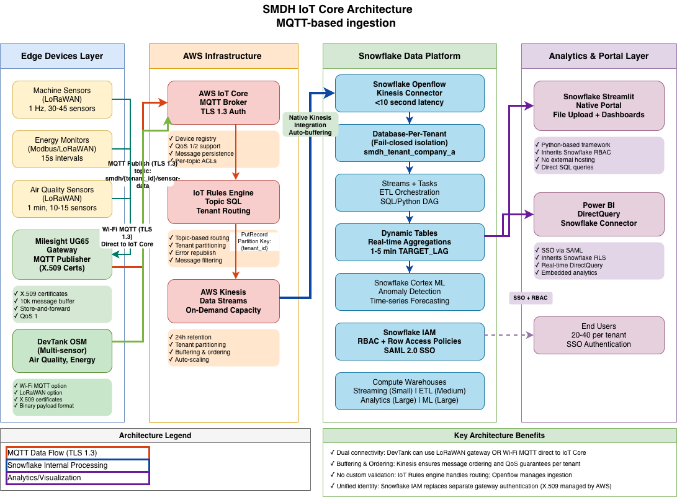
SMDH IoT Core Architecture

3.1 Data Ingestion Layer

3.1.1 AWS IoT Core (MQTT Broker)
Acts as the MQTT broker for all IoT devices. Maintains persistent connections with thousands of sensors, handles connection management, and routes messages to downstream services via the IoT Rules Engine.
Capabilities:
- MQTT v3.1.1 and v5.0 protocol support
- Device registry for managing X.509 certificates and metadata
- Connection state management, reconnection, and offline message queuing
- QoS 0, 1, and 2 guarantees for reliable message delivery
- Topic-based access control (ACLs) per tenant
- Built-in monitoring via CloudWatch metrics
Why it’s needed:
All sensor data arrives via MQTT through Milesight UG65 gateways and DevTank OSM devices, so AWS IoT Core provides the central authentication point for distributed edge devices, manages certificate lifecycles without custom application logic, keeps persistent connections for high-frequency sensors (1 Hz+), and integrates natively with Kinesis through the IoT Rules Engine.
Traceability
- FR-001: Enables MQTT protocol support for all sensor types
- FR-005: Maintains persistent connections with QoS guarantees
- NFR-001: Auto-scales to handle 26M+ messages/day
- NFR-003: Certificate-based authentication (X.509)

3.1.2 Kinesis Data Streams
Buffers and orders streaming data between IoT Core and Snowflake. Provides temporary storage for high-velocity data streams with guaranteed ordering per partition.
- IoT Core generates data faster than Snowflake can ingest individual messages
- Provides replay capability if downstream processing fails
- Maintains message ordering within tenant partitions
- Enables multiple consumers (future real-time analytics)
Traceability
- FR-002: Enables real-time processing pipeline
- NFR-001: Handles high-throughput streaming data
- NFR-002: Provides durability with multi-AZ replication
Required when using IoT Core for MQTT ingestion. Optional for HTTP if buffering is needed.

3.2 IoT Rules Engine
Routes and filters MQTT messages from IoT Core to Kinesis. Implements multi-tenant routing and error handling without custom code.
Capabilities:
- SQL-based topic pattern matching (e.g., smdh/{tenant_id}/+/sensor-data)
- Message transformation and enrichment
- Conditional routing (filter before forwarding)
- Error handling with configurable dead-letter topics
- CloudWatch metrics for monitoring
The IoT Rules Engine extracts tenant context directly from the MQTT topic path, uses that metadata to route each message to the correct per-tenant Kinesis partition, republishes failures to dedicated error topics for investigation, and therefore avoids adding brittle custom processing code to the ingestion pipeline.
Traceability
- FR-001: Routes MQTT messages based on tenant
- FR-004: Enforces tenant isolation via topic ACLs
- FR-005: Guarantees ordered delivery per partition

3.3 Snowflake Integration
Overview:
Kinesis streams integrate with Snowflake via the Snowflake Openflow Kinesis Connector (native integration). This is an external system to AWS but critical for the complete data pipeline.
Integration Requirements:
- Snowflake account must exist in eu-west-2 (same region as Kinesis)
- Cross-account IAM role configured in AWS to allow Snowflake to read from Kinesis
- Openflow connector configured per tenant to route Kinesis streams to Snowflake databases
- Each tenant gets isolated database: smdh_tenant_{tenant_id}
Key AWS Configuration for Snowflake Integration:
- IAM Role for Snowflake Openflow connector
  - Allows Snowflake to assume role and read Kinesis streams
  - Restricts access to specific Kinesis streams only
  - External ID required for security
- Secrets Manager Secret
  - Stores Snowflake private key for JWT authentication
  - Used by Snowflake to sign requests to Kinesis
  - Automatic rotation before expiry
- Kinesis Stream Naming
  - Stream: smdh-sensor-data-stream
  - Partitioned by {tenant_id} to route messages to correct tenant database
  - On-demand capacity scales automatically with message volume
Traceability
- FR-002: Real-time data flow from Kinesis to Snowflake
- FR-004: Tenant isolation enforced via partition keys
- NFR-002: High availability via multi-AZ Kinesis replication

3.4 Supporting Services

3.4.1 AWS Secrets Manager
Securely stores and rotates sensitive credentials like Snowflake private keys, API keys, and connection strings.
- Lambda functions need Snowflake credentials
- Enables automatic credential rotation
- Provides audit trail for credential access
- Encrypts secrets at rest and in transit
Traceability
- NFR-003: Secure credential management
- NFR-005: Automated rotation reduces operational burden

3.4.2 CloudWatch
Centralised monitoring and logging for all AWS services. Collects metrics, stores logs, and triggers alarms.
CloudWatch delivers a single pane of glass for system health, drives automated alerting when issues surface, captures the performance metrics needed for ongoing optimisation, and preserves a detailed audit trail that underpins compliance demands.
Traceability
- NFR-002: Monitoring for availability targets
- NFR-003: Audit logging for security
- NFR-005: Automated alerting reduces manual monitoring

4. Data Flow Patterns

4.1 MQTT Sensor Data Flow
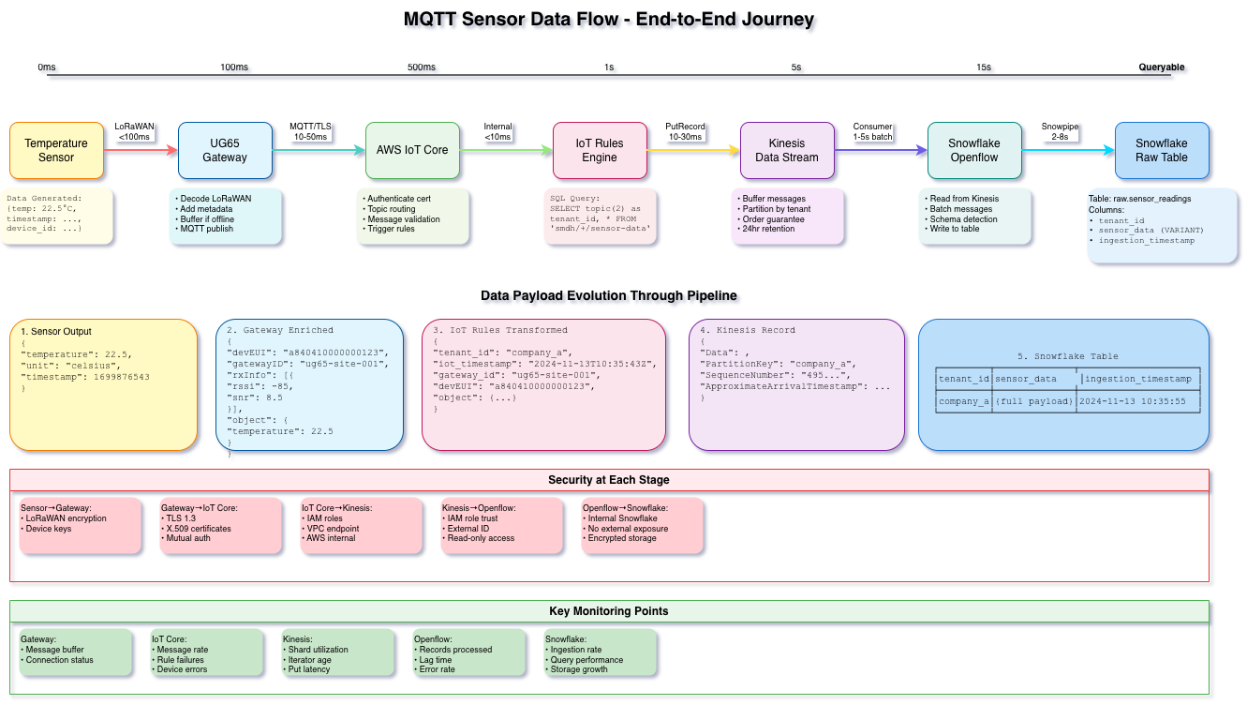
SMDH MQTT Data Flow
The diagram above illustrates the complete end-to-end journey of sensor data from edge devices through to queryable analytics tables in Snowflake. The architecture achieves approximately 15 seconds total latency from sensor reading to queryable data, with security controls enforced at each stage.
Scenario: Manufacturing facility with multiple sensor types sending continuous data
Devices in scope:
- Milesight UG65 LoRaWAN gateways (collect sensor data via 868 MHz radio)
- DevTank OpenSmartMonitor (air quality, energy, environment via Wi-Fi MQTT or LoRaWAN)
- Generic LoRaWAN sensors (temperature, vibration, state monitoring)

Pipeline Stages and Latency Breakdown
Stage 1: Sensor Generation (0ms baseline)
Temperature sensors, air quality monitors, and other IoT devices generate readings at frequencies ranging from 1 Hz (temperature, vibration) to 1 minute intervals (air quality). Each sensor produces a minimal payload containing timestamp, device identifier, and measurement values.
Example sensor output:
{
"temperature": 22.5,
"unit": "celsius",
"timestamp": "2024-11-13T10:35:43"
}
Stage 2: Gateway Enrichment (LoRaWAN: <100ms)
The Milesight UG65 Gateway receives LoRaWAN transmissions from sensors and performs critical preprocessing:
- Decode LoRaWAN protocol: Converts radio packets to JSON
- Add gateway metadata: Enriches with device identifiers, gateway location, signal strength (RSSI)
- Buffer if offline: Stores messages locally during network interruptions
- Prepare MQTT publish: Formats payload for AWS IoT Core
Gateway-enriched payload:
{
"deviceID": "a840410000000123",
"gatewayID": "ug65-site-001",
"rxInfo": {
"rssi": -85,
"snr": 8.5
},
"object": {
"temperature": 22.5
}
}
Stage 3: MQTT Publish to AWS IoT Core (TLS handshake: 10-50ms)
Both Milesight UG65 gateways and DevTank OSM devices publish to AWS IoT Core via MQTT over TLS 1.3:
- Topic structure: smdh/{tenant_id}/{site_id}/sensor-data
- Authentication: X.509 certificate per gateway (mutual TLS)
- Message validation: IoT Core verifies certificate and topic permissions
- Connection management: Persistent connection with automatic reconnection
- QoS guarantee: QoS 1 (at-least-once delivery)
Security controls at this stage: - TLS 1.3 encryption in transit - X.509 certificate authentication - Topic-based ACLs prevent cross-tenant publishing - Device certificate revocation supported
Stage 4: IoT Rules Engine Transformation (Internal routing: <10ms)
The IoT Rules Engine applies SQL-based transformation and routing:
SELECT *,
topic(2) as tenant_id,
topic(3) as site_id
FROM 'smdh/+/+/sensor-data'
Transformed payload with routing metadata:
{
"tenant_id": "company_a",
"timestamp": "2024-11-13T10:35:43.123",
"gateway_id": "ug65-site-001",
"deviceID": "a840410000000123",
"object": {...}
}
The Rules Engine validates message structure, extracts tenant context from the MQTT topic path, and routes each message to Kinesis using the tenant identifier as the partition key. This ensures ordered delivery per tenant and enforces data isolation.
Stage 5: Kinesis Data Stream Buffering (PutRecord API: 10-30ms)
Kinesis receives the enriched messages and provides:
- Partition by tenant: {tenant_id} ensures ordering per customer
- Message buffering: 24-hour retention window for replay capability
- Ordering guarantees: Sequential delivery within each partition
- Throughput management: On-demand mode auto-scales with message volume
Security controls: - IAM role-based access (only Snowflake Openflow connector can read) - VPC endpoint for private connectivity (optional) - Encryption at rest using AWS managed keys - CloudTrail audit logging for all API calls
Stage 6: Snowflake Openflow Connector (Consumer batch: 1-5s)
The Snowflake Openflow Kinesis Connector (native integration) continuously polls the Kinesis stream:
- Batch processing: Reads messages in micro-batches every 1-5 seconds
- IAM role trust: External ID-protected cross-account access
- Schema detection: Automatically maps JSON to Snowflake VARIANT columns
- Write to raw table: Inserts into smdh_tenant_{tenant_id}.raw.sensor_readings
Kinesis record format passed to Snowflake:
{
"Data": "...",
"PartitionKey": "company_a",
"SequenceNumber": "495...",
"ApproximateArrivalTimestamp": "..."
}
Stage 7: Snowflake Snowpipe Ingestion (Snowpipe latency: 2-8s)
Snowpipe (Snowflake’s continuous ingestion service) writes the data to the raw table:
Table: raw.sensor_readings Columns: - tenant_id (VARCHAR) - sensor_data (VARIANT) - stores full JSON payload - ingestion_timestamp (TIMESTAMP)
Final queryable record in Snowflake:
SELECT * FROM smdh_tenant_company_a.raw.sensor_readings;
tenant_id | sensor_data | ingestion_timestamp
company_a | {“deviceID”: “a840…”, “object”:…} | 2024-11-13 10:35:55.123
Total End-to-End Latency: Approximately 15 seconds from sensor reading to queryable table in Snowflake (worst case), with typical latency around 10 seconds under normal conditions.

Security at Each Stage
The diagram illustrates defense-in-depth security controls throughout the pipeline:
Stage | Security Mechanism
Sensor → Gateway | LoRaWAN encryption, device-specific keys
Gateway → IoT Core | TLS 1.3, X.509 certificates, mutual authentication
IoT Core → Kinesis | IAM roles, VPC endpoint (optional), AWS internal network
Kinesis → Openflow | IAM role trust, external ID, read-only access
Openflow → Snowflake | Internal Snowflake connector, no external exposure
Snowflake storage | Encrypted storage, database-per-tenant isolation

Key Monitoring Points
As shown in the diagram, the following metrics should be monitored at each component (detailed monitoring coverage in Section 10):
- Gateway: Message buffer depth, connection status, offline duration
- IoT Core: Message rate, connection errors, rule failures, device errors
- Kinesis: Shard utilisation, iterator age, put latency, throttling events
- Openflow: Records processed, lag time, error rate, batch size
- Snowflake: Ingestion rate, query performance, storage growth, task execution status

Data Payload Evolution Summary
The diagram’s “Data Payload Evolution Through Pipeline” section demonstrates how the JSON structure evolves:
- Sensor Output: Minimal data (temperature, timestamp)
- Gateway Enriched: Adds device/gateway metadata, signal quality
- IoT Rules Transformed: Adds tenant context and routing metadata
- Kinesis Record: Wraps in Kinesis envelope with partition key and sequence number
- Snowflake Table: Stored as VARIANT column with ingestion timestamp
This transformation preserves the complete data lineage whilst adding operational metadata at each stage for troubleshooting and audit purposes.

Why This Architecture
- MQTT-native throughout: All sensors and gateways use MQTT protocol natively (no conversion)
- Persistent connections: Handle continuous 1 Hz streams without polling overhead
- Strong authentication: X.509 certificates provide device identity and revocation capability
- Inherent multi-tenancy: Topic-based routing enforces tenant isolation from edge to database
- Minimal custom code: Kinesis provides buffering and ordering without Lambda functions
- Predictable latency: No validation layers or synchronous processing steps
- Cost-efficient: Serverless components scale to zero, pay only for actual usage

5. Multi-Tenancy Strategy
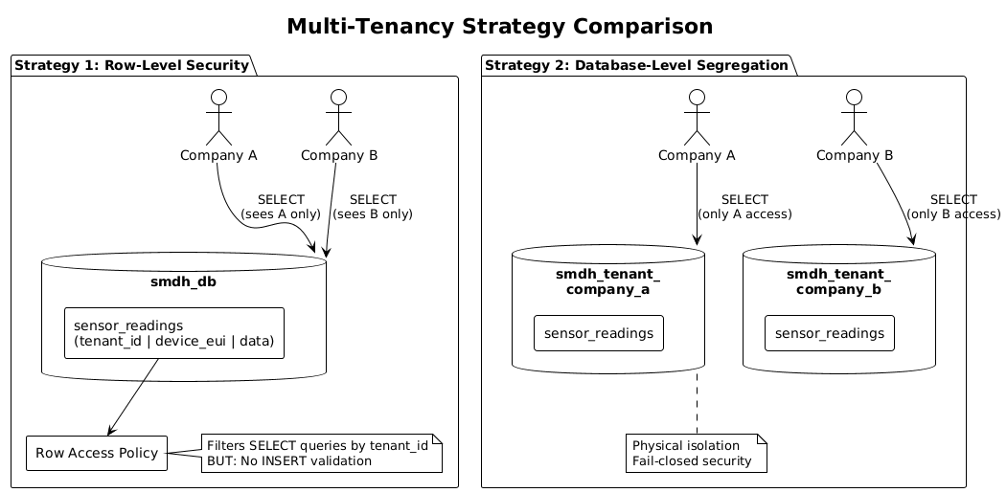
Multi-Tenancy Comparison

5.1 Isolation Levels
Layer | Isolation Method | Rationale
Device Level | Separate X.509 certificates per gateway | Prevents device spoofing, enables revocation
Topic Level | Topic ACLs enforce smdh/{tenant_id}/* path | Prevents cross-tenant topic access at IoT Core
Rules Level | IoT Rules extract tenant from topic | Validates tenant context before Kinesis routing
Partition Level | Kinesis partitioned by {tenant_id} | In-order delivery, isolation per tenant
Database Level | Separate database per tenant in Snowflake | Complete storage isolation
Application Level | Role-based access control in Snowflake | Users only see their tenant’s data

5.2 Why Database-per-Tenant?
Chosen approach: Each tenant gets their own Snowflake database (e.g., smdh_tenant_company_a)
Advantages:
- Fail-closed security: Wrong database name = error, not data leak
- Independent operations: Can maintain one tenant without affecting others
- Clear compliance: Physical separation satisfies most regulations
- Simple disaster recovery: Can restore single tenant
- Independent retention: Different data retention per tenant
Trade-offs accepted:
- More databases to manage (automated via IaC)
- Cross-tenant analytics require data sharing (rare requirement)

6. Scalability Considerations

6.1 Current Scale
Metric | Per Site | 30 Sites Maximum
Sensors | 5-10 | 150-300
Messages/day (1 Hz) | 432K-864K | 13-26M
Data volume/day | 50-200 MB | 1.5-6 GB
Concurrent users | 2-5 | 60-150

6.2 Scaling Strategy
Horizontal scaling points:
- IoT Core: Automatically scales to millions of connections
- Kinesis: On-demand mode scales with throughput
- Lambda: Concurrent execution scales to 1000s
- Snowflake: Multi-cluster warehouses for compute scaling
Vertical scaling points:
- Snowflake warehouse size: Start Small, scale to Large as needed
- Lambda memory: Start at 512MB, increase if processing is slow

7. AWS Account & Network Architecture

7.1 AWS Account Structure
Single-Account Strategy:
The SMDH platform operates in a single production AWS account in eu-west-2 (London region).
AWS Account: 123456789012 (smdh-production)
├─ Region: eu-west-2 (London) - Primary
├─ Services:
│ ├─ AWS IoT Core (Global via regional endpoint)
│ ├─ Kinesis Data Streams (Regional)
│ ├─ Secrets Manager (Regional)
│ └─ CloudWatch (Regional)
└─ High Availability: Multi-AZ within region
Rationale:
- Simplified billing and cost allocation
- Single security boundary for compliance
- No cross-account authentication complexity
- IoT Core and Kinesis are regional services (benefits from multi-AZ)

7.2 Network Architecture: No VPC Required
Architecture Principle: The SMDH platform uses only fully managed AWS services that do not require VPC hosting. IoT devices connect from the internet to public AWS endpoints with TLS encryption and X.509 certificate authentication.
Why we don’t need a VPC:
All SMDH AWS components are fully managed services that operate outside of VPC networking:
Service | Type | Network Access | VPC Required?
IoT Core | Managed | Public endpoint via internet | No
Kinesis | Managed | AWS API (internal) | No
Secrets Manager | Managed | AWS API (internal) | No
CloudWatch | Managed | AWS API (internal) | No
IAM | Managed | Control plane only | No
Simplified Architecture Flow:
Internet-connected Devices (Gateways/Sensors)
│
├─ TLS 1.3 on port 8883 (MQTT)
│
↓
AWS IoT Core (Managed Service, Public Endpoint)
│
├─ Regional endpoint: *.iot.eu-west-2.amazonaws.com
├─ X.509 certificate authentication
├─ Multi-AZ redundancy built-in
│
↓
IoT Rules Engine (Managed)
│
├─ SQL-based routing with tenant context
│
↓
Kinesis Data Streams (Managed Service)
│
├─ Multi-AZ by default
├─ Accessed via AWS API (no VPC)
│
↓
Snowflake Openflow Connector (External)
│
└─ Cross-account IAM role access
Benefits of no VPC architecture:
- ✓ Simpler architecture, fewer components to manage
- ✓ No NAT gateways, no subnet management, no CIDR planning
- ✓ Lower operational overhead and reduced costs
- ✓ Multi-AZ redundancy automatic with managed services
- ✓ No VPC limits or IP address exhaustion concerns
Security considerations:
While the IoT Core endpoint is internet-facing, this is mitigated through:
- X.509 certificate authentication (mutual TLS)
- Topic-based access control policies
- TLS 1.3 encryption in transit
- CloudWatch logging of all connection attempts

7.3 Network Security Controls
At IoT Core:
- TLS 1.3 Encryption - All MQTT connections must use TLS
- X.509 Certificate Authentication - Device identity verified
- Topic ACLs - Policy restricts devices to smdh/{tenant_id}/* topics only
- Connection Policies - Limits allowed actions per certificate
MQTT Topic Hierarchy:
smdh/{tenant_id}/{site_id}/sensor-data # Sensor readings (publish)
smdh/{tenant_id}/{site_id}/device-status # Device health/diagnostics (publish)
smdh/{tenant_id}/commands/{device_id} # Downlink commands (subscribe)
smdh/errors/{tenant_id} # Error republish topic
Example IoT Policy:
{
"Version": "2012-10-17",
"Statement": [
{
"Effect": "Allow",
"Action": "iot:Connect",
"Resource": "arn:aws:iot:eu-west-2:${AWS_ACCOUNT_ID}:client/smdh-*-TENANT_ID-*"
},
{
"Effect": "Allow",
"Action": "iot:Publish",
"Resource": [
"arn:aws:iot:eu-west-2:${AWS_ACCOUNT_ID}:topic/smdh/TENANT_ID/*/sensor-data",
"arn:aws:iot:eu-west-2:${AWS_ACCOUNT_ID}:topic/smdh/TENANT_ID/*/device-status"
]
},
{
"Effect": "Allow",
"Action": "iot:Subscribe",
"Resource": "arn:aws:iot:eu-west-2:${AWS_ACCOUNT_ID}:topicfilter/smdh/TENANT_ID/commands/*"
},
{
"Effect": "Allow",
"Action": "iot:Receive",
"Resource": "arn:aws:iot:eu-west-2:${AWS_ACCOUNT_ID}:topic/smdh/TENANT_ID/commands/*"
}
]
}
At Kinesis:
- IAM Role-based Access - Only Snowflake role can read
- Encryption at Rest - AWS managed keys (customer keys optional)
- CloudTrail Logging - All API calls logged

8. Security Architecture

8.1 Defense in Depth
Layer | Security Control
Network | TLS 1.3 for all MQTT connections, regional endpoints
Identity | X.509 certificates for devices (managed by AWS IoT)
Access | Topic ACLs + IoT policies restrict per tenant
Data | Encryption at rest (Kinesis) and in transit (TLS)
Secrets | Secrets Manager for certificate rotation
Monitoring | CloudTrail, CloudWatch metrics, Snowflake audit logs

8.2 Key Security Decisions
Device authentication: X.509 certificates (AWS IoT Core managed)
- Reason: Industry standard for IoT, can be revoked, non-repudiation
- Implementation: Auto-generate, store securely, rotate before expiry
- Fallback: Manual certificate generation if needed
Topic Isolation: MQTT topic patterns enforced by IoT policies
- Reason: Prevents cross-tenant message injection
- Example: Device with tenant_a cert cannot publish to smdh/tenant_b/*
- Enforcement: Topic ACLs at IoT policy level
Encryption in Transit: TLS 1.3 for all MQTT connections
- Reason: Protects credentials and data from eavesdropping
- Implementation: Mandatory via port 8883 (MQTT with TLS)
- Verification: Certificate hostname validation on device
User authentication: SSO via SAML in Snowflake
- Reason: Centralised identity management, MFA support
- Scope: Covers access to Streamlit portal and Power BI
- Enforcement: Snowflake role-based access control

9. Cost Optimisation

9.1 Serverless-First Approach
Why serverless?
- Pay only for actual usage (no idle costs)
- Auto-scaling included (no over-provisioning)
- No maintenance overhead (reduces operational cost)
Serverless components:
- IoT Core (MQTT broker - pay per message)
- Kinesis On-Demand (streaming - pay per shard-hour)
- Secrets Manager (pay per secret + API calls)
- CloudWatch (pay per metric + logs ingested)

9.2 Cost Control Mechanisms
Component | Cost Control Strategy
IoT Core | On-demand pricing, 26M messages/day well below limits
Kinesis | On-demand mode, auto-scales down to zero shards
Secrets Mgr | ~$0.40/secret/month, no per-call charges
CloudWatch | Log retention policies (90-180 days)
Snowflake | Auto-suspend warehouses, resource monitors

10. Operational Considerations

10.1 Monitoring Strategy
What to monitor (AWS components):
Metric | Source | Target | Threshold
IoT Connections | CloudWatch | Dashboard | Track active gateways
MQTT Messages | CloudWatch | Dashboard | Should be ~86K/sec peak
Message Processing | CloudWatch | Dashboard | <100ms latency
Connection Errors | CloudWatch | Alarm | >5 failures in 5 min
Certificate Expiry | CloudWatch | Alarm | <30 days until expiry
Kinesis Iterator Age | CloudWatch | Alarm | >60 seconds
CloudWatch Logs | CloudWatch | Dashboard | Parse error patterns
What to monitor (Snowflake components):
- Raw data ingestion rate
- Task execution success/failure
- Dynamic Table refresh latency
- Storage growth per tenant
- Query performance
How to implement:
- CloudWatch Dashboards: Real-time AWS metrics
- CloudWatch Alarms: SNS notifications for issues
- Snowflake System Views: Query ingestion_metrics
- Automated Reports: Daily health check summaries

10.2 Alerting Strategy
Critical Alerts (Page on-call):
- IoT Core connection failures >5 in 5 minutes
- Certificate expiring <7 days
- Kinesis iterator age >2 minutes
- Zero data for >30 minutes
Warning Alerts (Ticket):
- Kinesis iterator age >60 seconds
- Snowflake task failures >3 in 1 hour
- Connection errors >1 per minute
- Disk space low warnings
Information Alerts (Log only):
- Successful tenant connections
- Daily ingestion statistics
- Certificate rotation completions

10.3 Maintenance Windows
Zero-downtime operations:
- Certificate rotation: Deploy new certs before expiry (30-day window)
- IoT policy updates: Changes effective immediately, no device reconnect required
- Kinesis configuration: Modify partition count without data loss
- Snowflake changes: Execute during low-traffic periods (typically 02:00-04:00 UTC)
Regular maintenance:
- Certificate rotation (automated): Secrets Manager triggers before expiry
- CloudWatch logs cleanup: Automated via retention policies (90 days)
- IoT Core certificate expiry: Monitor via CloudWatch alarms
- Snowflake data archival: Automated via Time Travel and storage tiers
- CloudTrail logs: Retained in S3 for 90 days (compliance requirement)

11. Future Extensibility

11.1 Planned Enhancements
Enhancement | Architecture Impact
Real-time alerting | Add EventBridge for complex event processing

11.2 Architecture Flexibility
The architecture supports future changes through:
- Protocol agnostic core: Can add new ingestion methods
- Loosely coupled services: Can swap components independently
- Standard interfaces: Uses common formats (JSON, MQTT, HTTP)
- Cloud-native design: Can leverage new managed services

12. Decision Log

12.1 Key Architecture Decisions
Decision | Choice | Alternative Considered | Rationale
MQTT Broker | AWS IoT Core | EMQ X, Mosquitto | Fully managed, scales to millions, native AWS
Stream Processing | Kinesis (on-demand) | Kafka/MSK, SQS | Native integration, no cluster management
Data Warehouse | Snowflake | Redshift, BigQuery | Superior semi-structured data handling
Web Framework | Streamlit in Snowflake | React + ECS | Faster development, no separate infrastructure
Multi-tenancy | Database-per-tenant | Row-level security | Stronger isolation, simpler operations
Device Authentication | X.509 certificates | Pre-shared keys | Can be revoked, non-repudiation
Network Design | No VPC (managed only) | Custom VPC | Simpler, IoT needs internet-facing endpoint
Regional Deployment | Single region (eu-west-2) | Multi-region | Cost-effective, compliance, gateway proximity

12.2 Trade-offs Accepted
Trade-off | Benefit Gained | Risk Mitigation
MQTT-only (no HTTP) | Simpler architecture, lower latency | File uploads handled via Streamlit
Managed services lock-in | Reduced operations, high reliability | Standard protocols (MQTT, AWS APIs)
Internet-facing IoT endpoint | No NAT overhead, simpler network | Mitigated by X.509 certs + topic ACLs
Eventual consistency | Better performance, scalability | Design dashboards for eventual consistency
Single region | Simplified ops, cost optimization | Multi-region failover via Kinesis replication

13. Tenant Onboarding Strategy

13.1 Overview
Onboarding a new tenant involves configuring resources across AWS and Snowflake to ensure complete isolation, proper authentication, and correct data routing. This process should be automated through Infrastructure as Code (IaC).
For detailed step-by-step implementation instructions including scripts, SQL templates, and configuration files, see the Infrastructure Implementation Guide.

13.2 Onboarding Phases
The tenant onboarding process follows these high-level phases:
Phase | Component | Configuration Required | Responsible Team
1. Planning | Business Setup | Contract, SLAs, data volumes | Sales/Account Management
2. Identity | User Accounts | SSO setup, user list, roles | Identity Team
3. AWS Setup | IoT Core & Rules | X.509 certificates, topic ACLs | Platform Team
4. Snowflake Setup | Database & Roles | Database creation, RBAC setup | Data Team
5. Application | Portal Access | Streamlit configuration | Application Team
6. Validation | End-to-end Test | Data flow verification | QA Team
7. Production | Go-live | Monitoring, alerts, certificate mgmt | Operations Team

13.3 Key Architectural Decisions for Onboarding
Naming Convention:
- Tenant identifiers use lowercase alphanumeric (e.g., company_a)
- All resources follow pattern: smdh_tenant_{tenant_id}_*
- Snowflake database: smdh_tenant_{tenant_id}
AWS IoT Configuration:
- Each tenant gets unique X.509 certificates per gateway
- Topic ACLs enforce smdh/{tenant_id}/* pattern
- IoT policies restrict devices to tenant namespace only
Snowflake Isolation:
- Database-per-tenant for complete logical separation
- Separate schemas: raw, normalized, aggregated, analytics
- Role-based access control enforces data isolation
Gateway Registration:
- Thing registry tracks all Milesight UG65 and DevTank OSM devices
- Each gateway gets unique attributes (location, deployment date, site ID)
- Certificate lifecycle: 2-year validity with 30-day rotation reminder

13.4 Validation and Testing
Key validation points during onboarding:
Test | Description
MQTT Connection | Gateway connects to IoT Core with X.509
Message Ingestion | Data appears in Snowflake within 30s
Tenant Topic ACLs | Cross-tenant topic access is blocked
Data Routing | Kinesis partition matches tenant_id
User Access | SSO login shows only tenant data
Certificate Rotation | Cert update triggers successfully
Monitoring | CloudWatch alarms fire for errors

13.5 Lifecycle Management
Event | Action Required | Approx Timeline
Onboarding | Full setup per phases above | 2-4 hours automated
Scaling Up | Add warehouses, increase limits | 30 minutes
Scaling Down | Reduce warehouses, adjust retention | 30 minutes
Suspension | Disable ingestion, preserve data | 15 minutes
Reactivation | Re-enable ingestion, validate | 1 hour
Offboarding | Export data, remove resources | 4-8 hours

14. Implementation
Implementation details including step-by-step configuration procedures, SQL table definitions, AWS scripts, and tenant onboarding automation are documented in the Infrastructure Implementation Guide.

15. Conclusion
The SMDH AWS architecture is designed to meet core requirements with the simplest possible implementation:
- Single Protocol: MQTT native for all sensor data (no HTTP conversion)
- Managed Services Only: IoT Core, Kinesis, Secrets Manager, CloudWatch—no custom compute
- No VPC Complexity: Fully serverless, no network infrastructure to manage
- Multi-Tenant Isolation: Database-per-tenant approach in Snowflake
- Cost Effective: Pay-per-use pricing, no idle resources or over-provisioning
This architecture prioritises simplicity. By standardising on MQTT and using only managed AWS services, we eliminate custom validation layers, reduce operational overhead, and minimise the attack surface.

15.1 What This Architecture Provides
Core capabilities delivered:
- MQTT ingestion from Milesight UG65 gateways and DevTank OSM sensors
- Persistent connections with QoS guarantees for high-frequency data (1 Hz)
- Multi-tenant data isolation from device certificates through to Snowflake databases
- Real-time streaming pipeline with <1 minute end-to-end latency
- Certificate-based device authentication and topic-level access control

15.2 Known Limitations
This minimal design does not include:
Technical Limitations:
Missing Capability | Impact | Future Enhancement Path
API-based sensor alerts | No real-time alerting on sensor threshold violations | Add EventBridge + Lambda for rule engine
HTTP ingestion | Cannot accept sensor data via HTTP/REST APIs | Add API Gateway + Lambda validation layer
Edge processing | All data processing happens in cloud | Deploy AWS IoT Greengrass to gateways
Multi-region failover | Single region (eu-west-2) deployment only | Add Kinesis cross-region replication
Custom dashboards | Limited to Streamlit within Snowflake | Deploy React/Next.js app with API Gateway
Operational Limitations:
Missing Capability | Impact | Future Enhancement Path
Self-service tenant onboarding | Platform team must manually provision each new tenant | Build admin portal with Terraform automation
Automated certificate rotation | Certificates require manual renewal before expiry | Implement Lambda-based rotation with ACM
Self-service gateway registration | Operators cannot register new gateways without platform team | Create gateway registration portal in Streamlit
User management portal | SSO users managed manually in Snowflake | Build identity management UI
Configuration management | All IaC changes require platform team deployment | Create self-service configuration portal
Operational model: All configuration is manual and requires platform team intervention. No self-service capabilities are implemented. This approach minimises development effort but creates scaling challenges as tenant count grows.
Why manual operations don’t scale:
Each new tenant requires platform team effort across six phases (per Infrastructure Implementation Guide):
Phase | Activities | Time
1. Planning | Gather requirements, define SLAs, document sensor counts | 30 min
2. Identity Setup | Create AWS/Snowflake accounts, assign roles | 30 min
3. AWS IoT Setup | Thing registry, X.509 certificates (per site), policies, topic ACLs, IoT Rules, SNS topics | 45 min
4. Snowflake Setup | Database creation, schemas (raw/normalized/aggregated), tables, streams, tasks, roles, users | 45 min
5. Application | Streamlit portal configuration, UI customisation | 30 min
6. Validation | E2E testing, MQTT connection, data routing, ACL verification, monitoring checks | 30 min
Total per tenant |  | 3.5h
Scaling arithmetic: - 5 tenants = 17.5 hours total (manageable for small team) - 15 tenants = 52.5 hours (1.5 weeks of full-time work) - 30 tenants = 105 hours (2.5 weeks of full-time work)
This only accounts for initial onboarding. Ongoing operational overhead includes: - Certificate rotation every 2 years per gateway (30 min each) - User additions/removals (15 min each) - Gateway registrations (20 min per new site) - Troubleshooting and support (variable)
The linear growth in operational overhead makes this approach unsustainable beyond 10-15 customers without automation.
Design philosophy: Start with the minimum viable architecture. Add complexity only when business requirements justify the operational overhead.
The AWS layer is deliberately minimal—just four core services orchestrate all sensor data ingestion. Snowflake handles all data processing, analytics, and user-facing applications. This separation keeps the AWS footprint small, predictable, and easy to operate.

Appendix A: Component Mapping
Business Requirement | Technical Component | AWS Service | Status
Receive MQTT sensor data | MQTT broker + Rules Engine | IoT Core + IoT Rules | Active
Buffer streaming data | Message queue | Kinesis | Active
Store sensor data | Data warehouse | Snowflake (external) | Active
Upload files | Web portal | Streamlit (Snowflake) | Active
Manage credentials | Secrets store | Secrets Manager | Active
Monitor system | Observability | CloudWatch | Active
Send alerts | Notification | SNS | Active
Geo-distributed apps | Edge processing | IoT Greengrass | Future
Complex event processing | Real-time rules | EventBridge | Future

Appendix B: Glossary
Term | Definition
MQTT | Message Queuing Telemetry Transport - IoT communication protocol
LoRaWAN | Long Range Wide Area Network - IoT radio protocol
JWT | JSON Web Token - Authentication token format
CDC | Change Data Capture - Tracking data modifications
VARIANT | Snowflake data type for semi-structured data
Dynamic Tables | Snowflake feature for materialized views with auto-refresh
Streamlit | Python framework for data applications
X.509 | Standard for public key certificates
SAML | Security Assertion Markup Language - SSO protocol
IaC | Infrastructure as Code - Managing infrastructure through code

